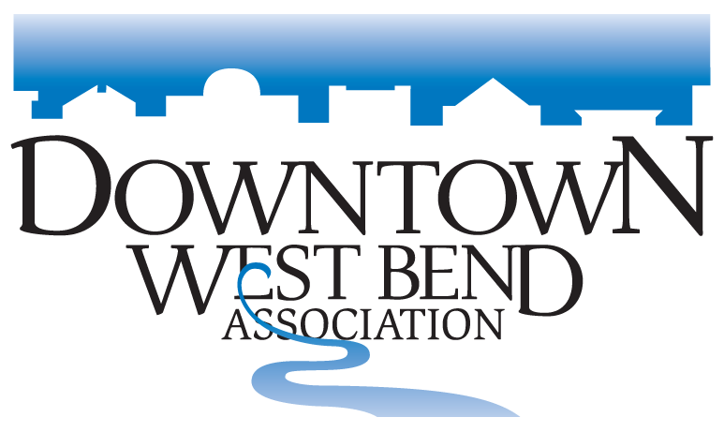

Sept 3rd, 2023
Wheel on Main Food Vendor Agreement

Business Name: ________________________________________________________
Contact: ______________________________________________________________
Email: ________________________________________________________________
Phone: _______________________________________________________________
Please make sure the contact information is correct.

____ Yes, we are interested in being a food vendor and providing food for sales during the 2023 Wheels on Main Event Sept 3rd 2023
____ Yes, we will contact the DWBA 1 week prior to our date if we need to cancel a scheduled time.
____ Yes, we plan to offer family friendly food options in additional to specialty menu items
____ Yes, I will send our images, marketing materials and links to Gena@downtownwestbend.com to be listed on the website and social media. (Please check https://wheelsonmain.weebly.com/) to ensure your information is correct prior to the event)
___ Yes, I will ensure that I have all the proper temporary food permit and display a copy at the event.

____ We confirm that we will be at Wheels on main 6am to set up and be ready to serve food by 9am until 4pm

If you have questions, please contact Gena@downtownwestbend.com or 262-338-3909

Signature: ___________________________________________________ Date: __________________
Please return this form to the DWBA ASAP, no later than July 31st

For marketing – (People ask all the time) purposes please make sure you plan the menus and try to have them to us the week before so we can post on social media and the Website .
You are welcome to fill out this form take a picture & text to 262-305-0861
Or email this form back to gena@downtownwetbend.com

